Part 1:
Class,
By now, you are aware the book provides the solutions to the exercises assigned. Thus, half of the battle in "having some kind of idea" on how to "solve the exercises" has been accomplished.
Finance is about interpreting/analyzing given numbers or calculations on current financial status or performance. Hence, numbers alone will not tell the story and intended future strategy.
In recreating the solutions, you are expected to demonstrate an understanding of both concept and problem solving. This can be achieved as follows:
Excel: Use formulas to connect the calculations of given numbers. Formulas help trace the numbers (cells) used to calculate the answers. You can also provide the plain numbers in each cell if you prefer. Just be sure your work is properly labeled and organized.
Word: Provide the numeric solution of the problem. Be sure to present your work organized and properly labeled. Use "Tables" or "Columns" to provide information that it is easy to read and follow.
After either option above is selected, answer the exercise questions or provide an assessment by explaining what the numbers mean. Analyze how concepts were applied to problem solving by writing a 200-250 words response /assessment to demonstrate your understanding of such. Cite as needed.
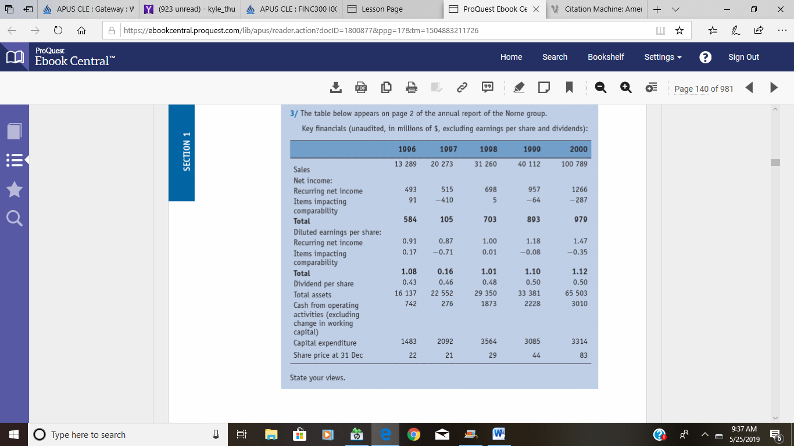

Part 2:
Class,
By now, you are aware the book provides the solutions to the exercises assigned. Thus, half of the battle in "having some kind of idea" on how to "solve the exercises" has been accomplished.
Finance is about interpreting/analyzing given numbers or calculations on current financial status or performance. Hence, numbers alone will not tell the story and intended future strategy.
In recreating the solutions, you are expected to demonstrate an understanding of both concept and problem solving. This can be achieved as follows:
Excel: Use formulas to connect the calculations of given numbers. Formulas help trace the numbers (cells) used to calculate the answers. You can also provide the plain numbers in each cell if you prefer. Just be sure your work is properly labeled and organized.
Word: Provide the numeric solution of the problem. Be sure to present your work organized and properly labeled. Use "Tables" or "Columns" to provide information that it is easy to read and follow.
After either option above is selected, answer the exercise questions or provide an assessment by explaining what the numbers mean. Analyze how concepts were applied to problem solving by writing a 200-250 words response /assessment to demonstrate your understanding of such. Cite as needed.
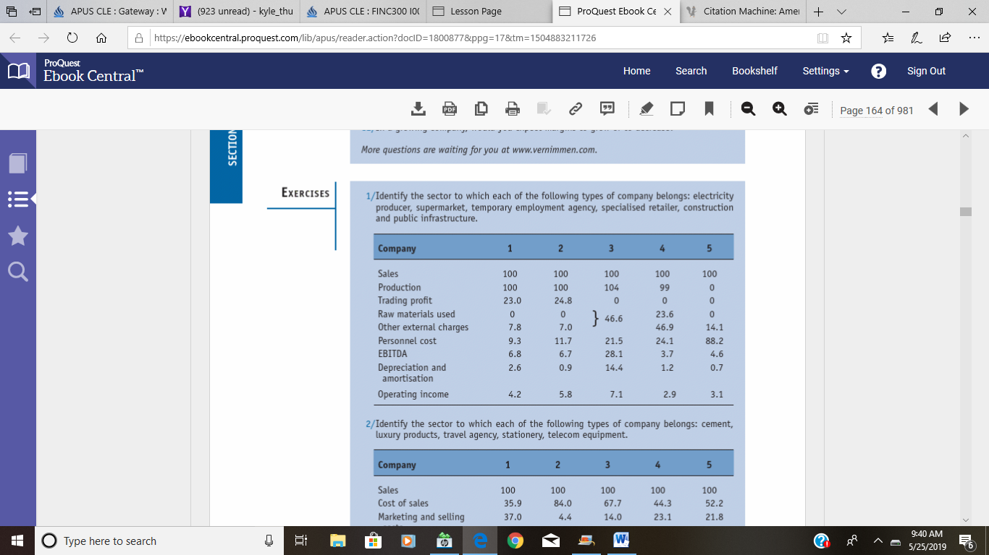

Part 3:
Class,
By now, you are aware the book provides the solutions to the exercises assigned. Thus, half of the battle in "having some kind of idea" on how to "solve the exercises" has been accomplished.
Finance is about interpreting/analyzing given numbers or calculations on current financial status or performance. Hence, numbers alone will not tell the story and intended future strategy.
In recreating the solutions, you are expected to demonstrate an understanding of both concept and problem solving. This can be achieved as follows:
Excel: Use formulas to connect the calculations of given numbers. Formulas help trace the numbers (cells) used to calculate the answers. You can also provide the plain numbers in each cell if you prefer. Just be sure your work is properly labeled and organized.
Word: Provide the numeric solution of the problem. Be sure to present your work organized and properly labeled. Use "Tables" or "Columns" to provide information that it is easy to read and follow.
After either option above is selected, answer the exercise questions or provide an assessment by explaining what the numbers mean. Analyze how concepts were applied to problem solving by writing a 200-250 words response /assessment to demonstrate your understanding of such. Cite as needed.
